ITA0435 – STATISTICS WITH R PROGRAMMING FOR VISUALIZATION
NAME ; R.SABARISH
REG NO : 192324092
R LAB EXPERIMENTS
1.Create numeric, character, and logical vectors and display type and content.
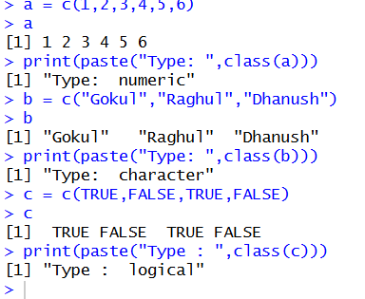
a = c(1,2,3,4,5,6)
a
print(paste("Type: ",class(a)))
b = c("Gokul","Raghul","Dhanush")
b
print(paste("Type: ",class(b)))
c = c(TRUE,FALSE,TRUE,FALSE)
c
print(paste("Type : ",class(c)))

2.Create labeled matrices (5×4, 3×3, 2×2) filled by row/column.
a = matrix(1:20,nrow=5,ncol=4)
a
b = matrix(1:9,nrow=3,ncol=3)
b
c = matrix(1:4,nrow=2,ncol=2)
c
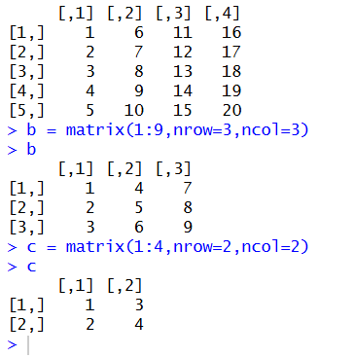

3. Write an R program to create and display a 3D array with specified rows, columns, and tables.
a = 1.24
arr = array(a, dim=c(2,3,4))
arr
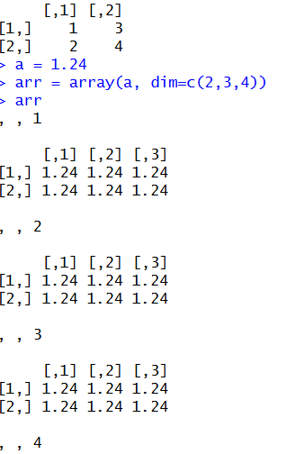

4. Create arrays from vectors with dimension names, print specific elements.
a = 1:8
b = array(a, dim=c(2,2,2))
b
print(b[2,1,2])

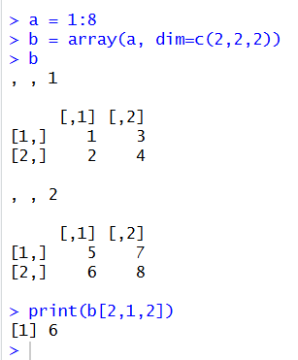

5. Create and manipulate factor variables (e.g., women’s dataset heights, random LETTERS sample)
a = c("Short","Medium","Tall","Medium","Tall","Short")
b = factor(a)
print(b)
set.seed(10)
c= sample(LETTERS[1:5],8,replace = TRUE)
d = factor(c)
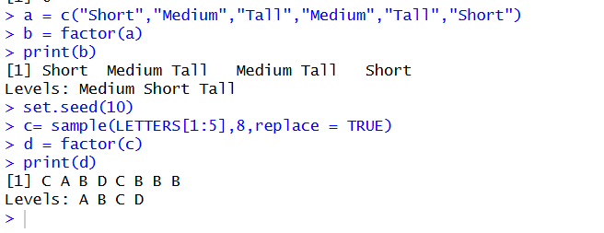
print(d)

6. Create an R list containing vectors, matrices, and functions; display contents.
a = c(1,2,3,4)
b = matrix(1:6, nrow = 2,ncol =3)
c = function(x)x^2
mylist=list(Vector = a, Matrix = b , Function = c)
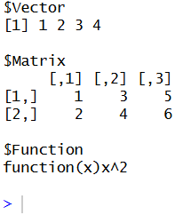
print(mylist)

7. Write R programs for basic tasks: Factors of a number, generate a vector of 10 random integers between -50 and 50, print numbers 1–100 with FizzBuzz logic.
n<-12L
factors<- integer(0)
for(i in seq_len(n)){
if(n %% i == 0L){
factors <-c(factors,i)
}
}
print("factors of the number:")
print(factors)
set.seed(123)
print("10 random integers:")
print(sample(-50:50,10,replace=TRUE))
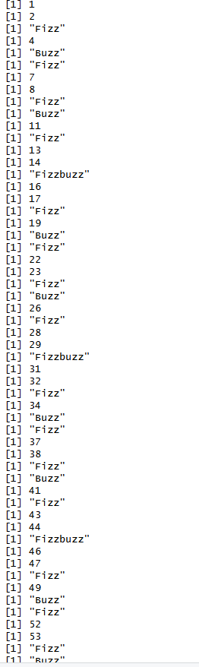
for(i in 1:100){
if(i %% 15 == 0) print("Fizzbuzz")
else if (i %% 3 == 0) print("Fizz")
else if (i %% 5 == 0) print("Buzz")
else print(i)
}

OUTPUT :

8. Generate random numbers from a normal distribution; count occurrences.
set.seed(123)
x <- rnorm(100)
y<-(table(round(x)))
print(as.data.frame(y))
OUTPUT :
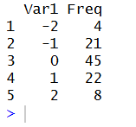

9. Create empty plots with specified axis limits.
rm(c)
plot(1, type = "n",
xlim = c(0,10),
ylim = c(0,100),
xlab = "x axis",
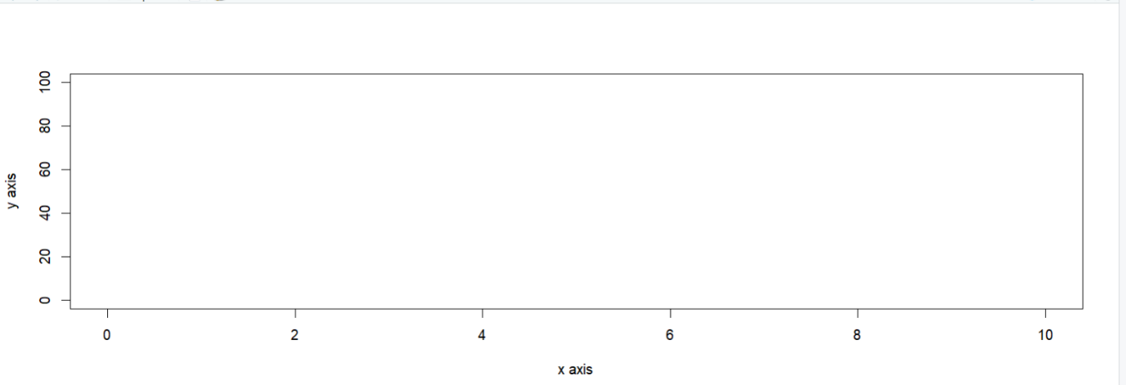
ylab = "y axis")

10. Create and explore a data frame exam_data with name, score, attempts, and qualifying fields. Perform extract, add row/column, sort, save to file.
x <- data.frame(
name = c("Anu","Bala","Charan","Divya","Esha"),
score = c(85,62,90,75,88),
attempts = c(1,3,2,2,1),
qualify = c("yes","no","yes","no","yes")
)
x <-rbind(x, data.frame(name="Farhan",score=70,attempts=3,qualify="no"))
x$grade <- c("A","C","A+","B","A","B")
x <- x[order(-x$score),]
write.csv(x,"x.csv",row.names=FALSE)
print(x)
OUTPUT :
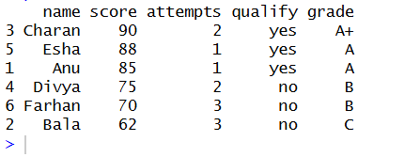

11. Write an R program to read a .csv file and display contents.
data <- read.csv("students_copy.csv")
print("Contents of the CSV file:")
print(data)

OUTPUT :
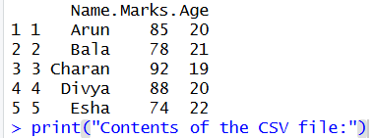

12. Perform data reshaping on air quality dataset: melt, cast, compute monthly averages for Ozone, Solar.R, Wind, and Temperature.
data("airquality")
result <- aggregate(cbind(Ozone, Solar.R, Wind, Temp) ~ Month,
data = airquality,
FUN = mean,
na.rm = TRUE)
print("Monthly average values:")
print(result)
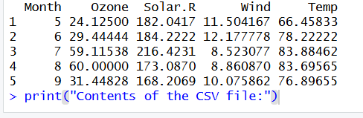

13. Combine multiple arrays row-wise
rm(list = ls())
a <- c(1, 2, 3)
b <- c(4, 5, 6)
c <- c(7, 8, 9)
d <- rbind(a, b, c)
print("Combined arrays (row-wise):")
print(d)

14. Explore and manipulate ChickWeight dataset (sorting, melting, casting by Diet).
data("ChickWeight")
head(ChickWeight)
sorted <- ChickWeight[order(ChickWeight$weight), ]
print(sorted)
aggregate(weight ~ Diet, ChickWeight, mean)

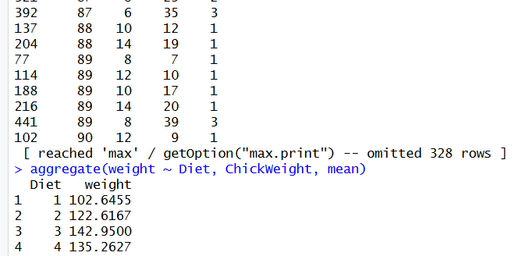
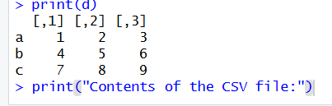
OUTPUT :

15. Perform EDA on iris dataset: dimensions, summary, standard deviation,quantiles, grouping by Species, pivot table, categorical grouping with Sepal.Length categories.
data("iris")
dim(iris)
summary(iris)
sapply(iris[,1:4], sd)
quantile(iris$Sepal.Length)
aggregate(. ~ Species, iris, mean)

OUTPUT :
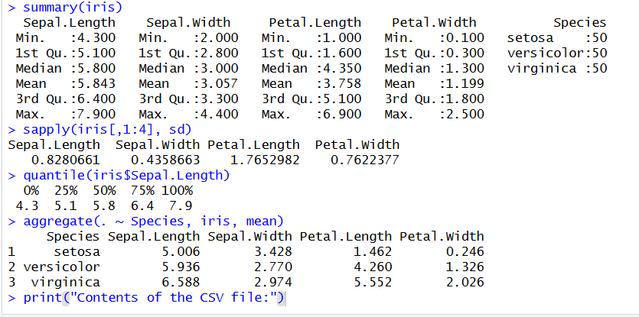

16. Explore USArrests dataset: summary statistics, state with largest rape arrests, max & min murder rates, correlation among features, states above median assault arrests and bottom 25% for murder, visualization with histogram, density, scatterplots, bar graphs.
data("USArrests")
summary(USArrests)
which.max(USArrests$Rape)
max(USArrests$Murder)
min(USArrests$Murder)
cor(USArrests)
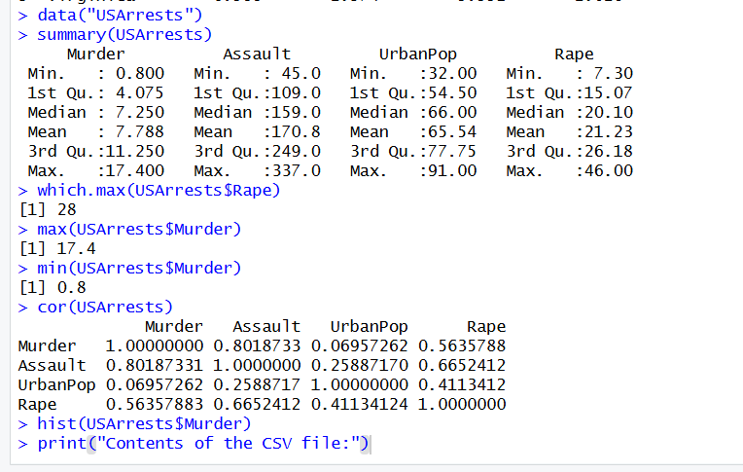
hist(USArrests$Murder)

OUTPUT :

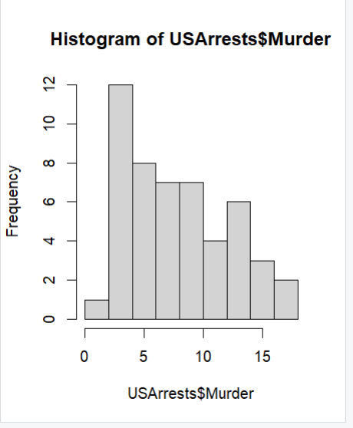

17. Explore Titanic dataset: bar chart of survival vs class, modify plot by gender, histogram of Age.
data("Titanic")
t <- as.data.frame(Titanic)
barplot(table(t$Class, t$Survived), main="Survival vs Class", beside=TRUE)
barplot(table(t$Sex, t$Survived), main="Survival vs Gender", beside=TRUE)
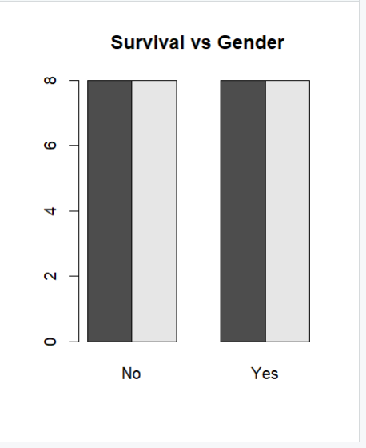

18. Create graphs in R: boxplot, histogram, bar plot, line chart, scatter plot.
x <- c(10, 20, 30, 40, 50)
y <- c(5, 15, 25, 35, 45)
par(mfrow = c(2, 3))
boxplot(x, main="Boxplot", col="lightblue")
hist(x, main="Histogram", col="lightgreen")
barplot(x, main="Bar Plot", col="orange", names.arg=c("A","B","C","D","E"))
plot(x, type="l", main="Line Chart", col="blue")
plot(x, y, main="Scatter Plot", col="red")

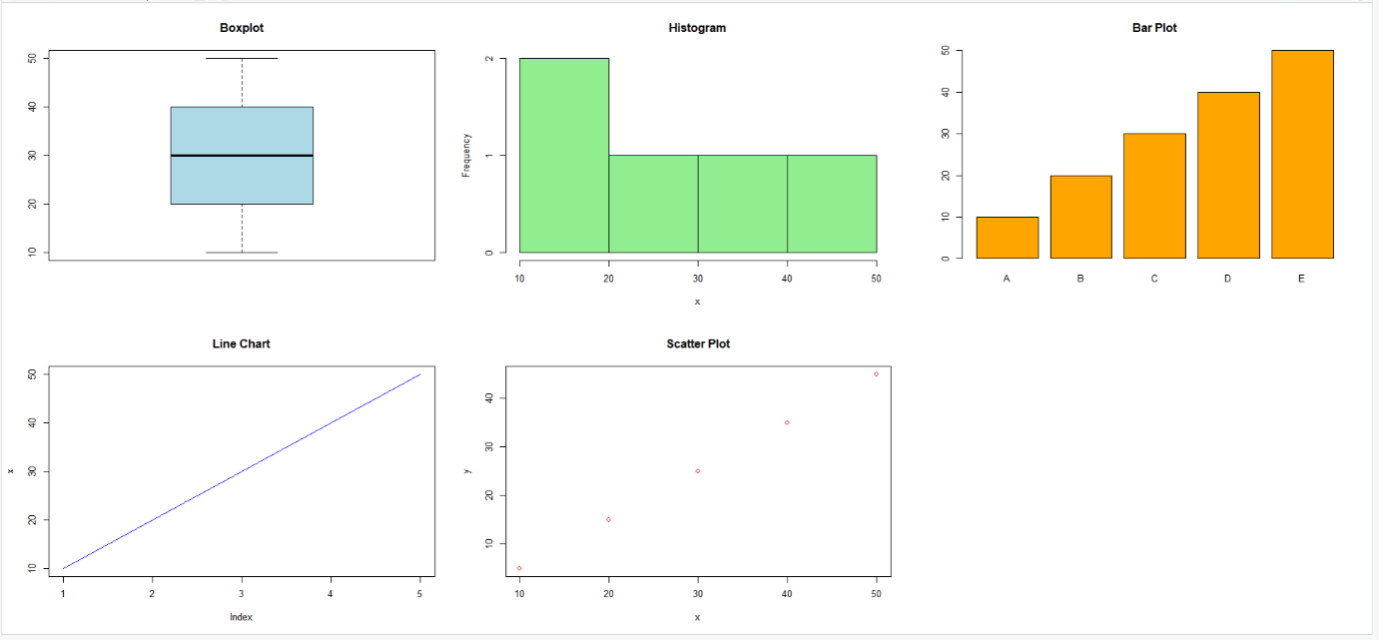
19. Build a regression model on advertising dataset (Sales ~ Spend) and predict Sales.
Spend <- c(10, 20, 30, 40, 50)
Sales <- c(15, 25, 35, 45, 55)
model <- lm(Sales ~ Spend)
predict(model, data.frame(Spend = 60))
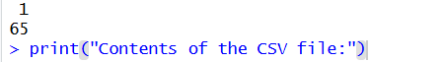

20. Create multiple regression model using ChickWeight dataset with “Time” and “Diet” as predictors; predict weight and compute model error.
data("ChickWeight")
m <- lm(weight ~ Time + Diet, data = ChickWeight)
p <- predict(m)
mean((ChickWeight$weight - p)^2)
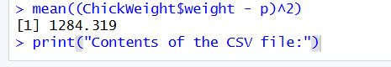

21. Randomly split iris dataset into train/test (80/20), build logistic regression (Species ~ Petal.Length + Petal.Width), predict, and evaluate with confusion matrix.

data("iris")
iris <- subset(iris, Species %in% c("setosa", "versicolor"))
m <- glm(Species ~ Petal.Length + Petal.Width, data=iris, family=binomial)
p <- ifelse(predict(m, type="response") > 0.5, "versicolor", "setosa")
table(p, iris$Species)

